Name: ______________________________

MA 101 – QUIZ #3B

PART I – Complete each question: Show your work (4 marks each)

In a fast food outlet a meal is sold for $6.00 per meal. To get started, the owner must invest $15,000.00 for fixed costs. He further calculates that it will cost him $3.50 per meal.
  - How many meals must he sell to break even?
  - If he decides to amortize his fixed costs over 30 months at $500.00 per month, how many meals must he sell to make a profit of $1,000.00 per month?
- The supply and demand function are determined by the equations:
(i) Supply: P = 2Q – 5
(ii) Demand: 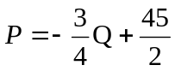
a) Determine the equilibrium point.
b) At what price are you unable to sell anything?
- Maximize f(x,y) = 4x + 2y
subject to
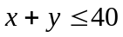

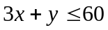

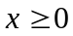

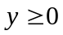

Hint:
Sketch the feasibility set and test each corner.
Part II – Complete each question: Sketch a graph for #1, #2.

- Find the equation of a line passing through (-3,1) and (2,3)
(3 marks)
y
x
- Find the equation of a line parallel to 2y – x = 6 and passing through (2,1)
(3 marks)
y
x
- Solve the system (2 marks)
